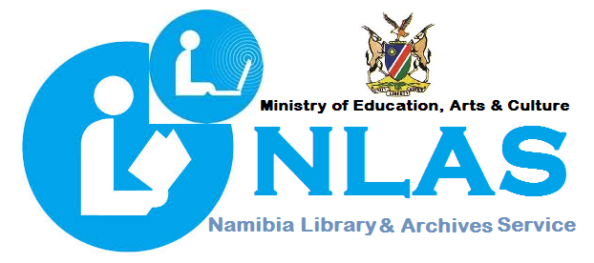

DIRECTORATE OF NAMIBIA LIBRARY AND ARCHIVES SERVICE (NLAS)

**NLAS OVERVIEW**

**THE NAMIBIA LIBRARY AND ARCHIVES SERVICE (NLAS**) is a central agency for the implementation of National and International standards relating to Library and Information work. Its purpose is to secure equal access to knowledge and information for lifelong learning by creating and maintaining professional expertise and nationwide network of libraries/information centers. NLAS is operating under the Act of Parliament, the Namibia Library and Information Service Act, Act No. 4 of 2000.

**The Directorate is having five (5) Sub-divisions, namely:**

**1. THE PUBLIC LIBRARY SERVICE (CLS)**

The Public Library Service is mandated to facilitate the development of information and computer literacy skills through community libraries.

Ensure that citizens have access to all sorts of information in all formats, (including Braille and audio books for the visually impaired library users).

Set standards to support oral tradition and indigenous knowledge, provide facilities to support individual and self-conducted education (Open Distance Learning), as well as formal education at all levels.

Facilitate the establishment of new community libraries, monitor and evaluate all library activities countrywide.

Centrally procure, process (cataloguing and classification), distribute library materials, collect and compile national statistics.

Identify training needs and facilitate the training. Assist with ICT deployment to all community libraries in Namibia and train all staff members, to be able to train community members and create and maintain the National community library catalogue.

**Currently public library service boasts a network of sixty-five (65) public libraries in all fourteen (14) regions.**

**2. EDUCATION LIBRARY SERVICE (ELS)**

The Education Library Service supports the school curriculum, by providing instructional information resources, teach skills on how to access and retrieve information for lifelong learning.

ELS help develop and sustain in children the habit and enjoyment of reading and proper use of information; assist more than 1894 schools, (EMIS 2019), around the country, in developing functional school libraries by providing effective and adequate access to resources in all schools in order to teach learners the necessary skills to become independent users of information.

ELS centrally procure, catalogue, classify and maintains the national school Library catalogue. In addition, ELS train Teachers in the general management of school libraries and information literacy.

**3. THE MINISTERIAL LIBRARY SERVICE (MLS)**

The Ministerial Library Service provides professional expertise to supervise, support and coordinate special library and information services in government. At present, the Ministry of Education through NLAS provided librarians to 14 libraries in different Ministries.

The main goal of ministerial libraries is to provide technical and scientific information to decision-makers, researchers, students, business community, technicians and other professionals covering needs and services on key areas of the national economy. At present 17 Ministerial/special libraries operate under Government Ministries.

**4. THE NATIONAL LIBRARY OF NAMIBIA (NLN)**

The National Library of Namibia supports education and research through access to national and international information resources, and collects and preserves the nation’s published intellectual heritage through legal deposit and book purchases. It also renders bibliographic services and serves as the national bibliographic agency e.g. facilitating the allocation of the International Standard Serial Numbers (ISSN), and International Standard Book Numbers (ISBN) to individuals and publishers/producers.

**5. THE NATIONAL ARCHIVES OF NAMIBIA (NAN)**

The National Archives of Namibia is operating under the Archives Act, Act No. 12 of 1992. It is entrusted to maintain the institutional memory of government offices, ministries, agencies, regional councils and parastatals; collects and preserves the nation’s history and unpublished documentary heritage; and supports education and research by providing access to these resources. NAN is also mandated to supervise and provide training in records management in all government offices, ministries, agencies, regional councils and parastatals.